**Command module:**

* Command is used to execute the raw Linux command
* Here idempotent is not guaranteed
* So, try to reduce command as much as possible
* Use this only when there is no other option. Try to give idempotence with command

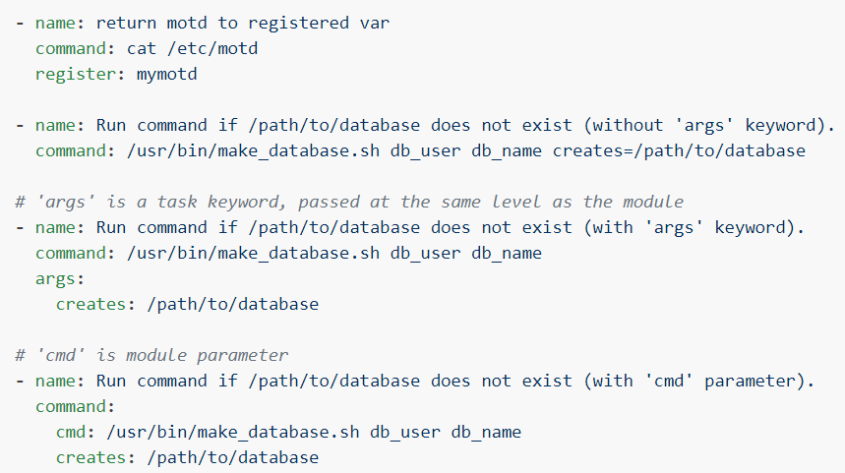

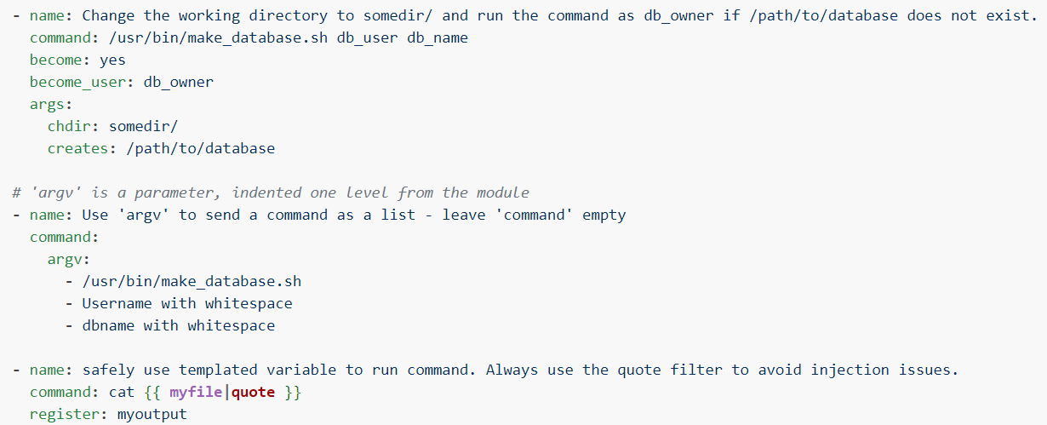

**Arguments:**

**creates**



* If we use **“creates”** argument along with **“command”** module to create a file. Then, if the file already exists. It won’t create the file

**removes**



* Same for the removes as well. If the file doesn’t exist, then this step won’t get executed.

**Shell module:**

* There is no much difference between command and shell
* Shell is only used in Linux whereas command can be used for another OS. It will pick the default shell from the OS and runs the command
* It is used for multi OS environment
* Shell is useful for running shell scripts

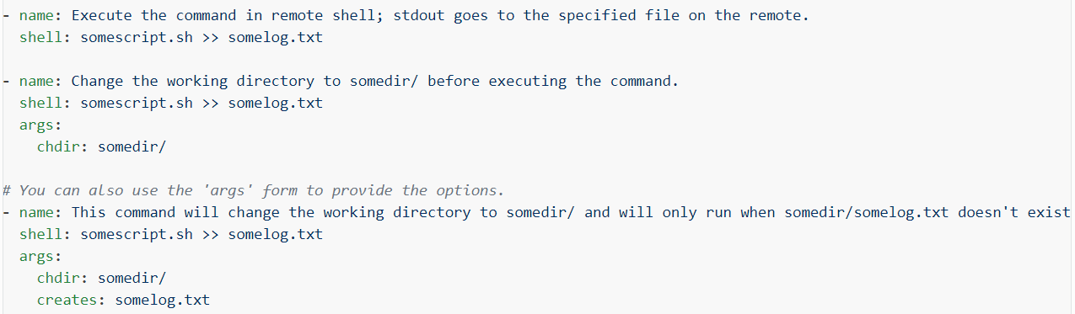

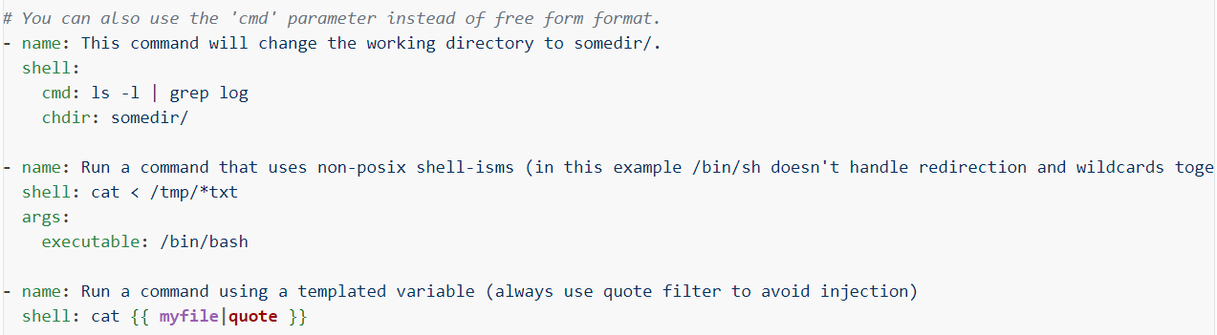

* **“creates”** and **“removes”** options here works the same as in **“command”** module.

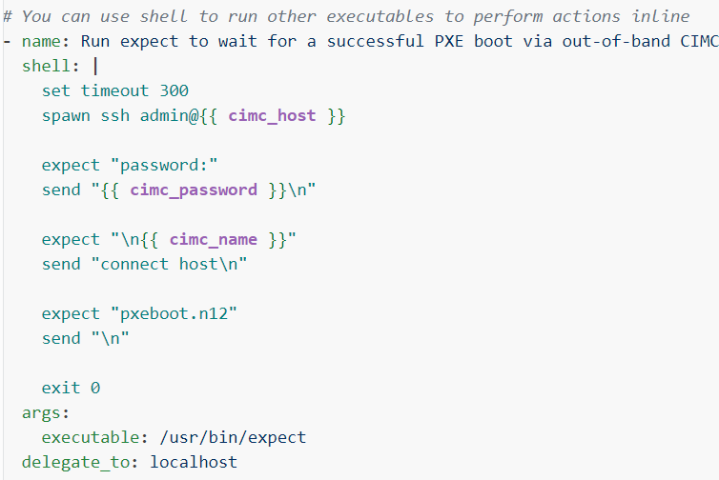

* The shell module takes the command name followed by a list of space-delimited arguments. It is almost exactly like the command module but runs the command through a shell (/bin/sh) on the remote node.
* For Windows targets, use the win_shell module instead.

**Raw module:**

* This is useful and should only be done in two cases. The first case is installing python-simplejson on older (Python 2.4 and before) hosts that need it as a dependency to run modules, since nearly all core modules require it. Another is speaking to any devices such as routers that do not have any Python installed. In any other case, using the shell or command module is much more appropriate. Arguments given to raw are run directly through the configured remote shell. Standard output, error output and return code are returned when available. There is no change handler support for this module.

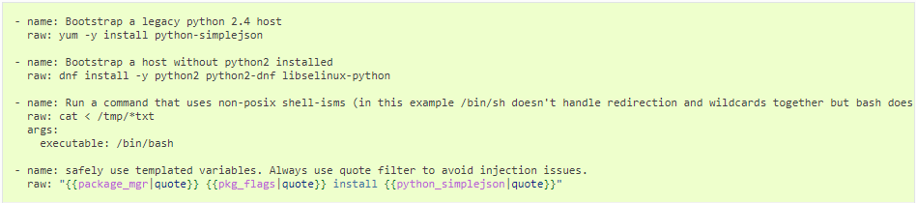

**Script module:**

* The script module is used to copy the local scripts to remote servers and execute.
* The local script at path will be transferred to the remote node and then executed.
* This module does not require python on the remote system, much like the raw module.
* This module is also supported for Windows targets.

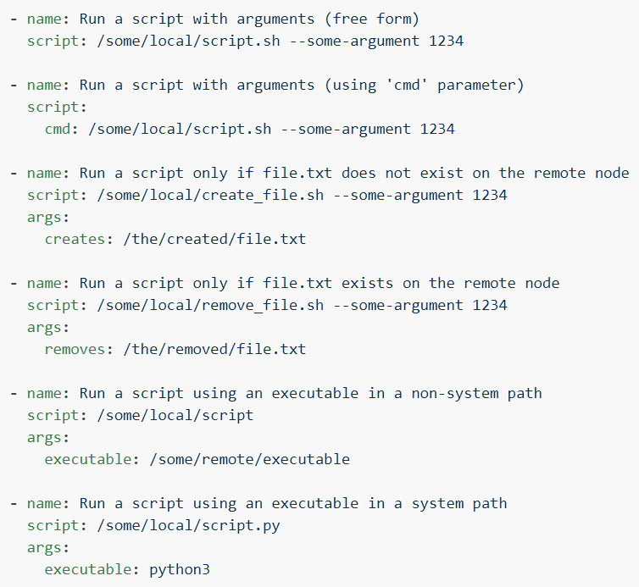

* **“creates”** and **“removes”** arguments are available here also. Which works the same way